03 JUNE 2026
TASK 1:

OUTPUT SCREENSHOT:
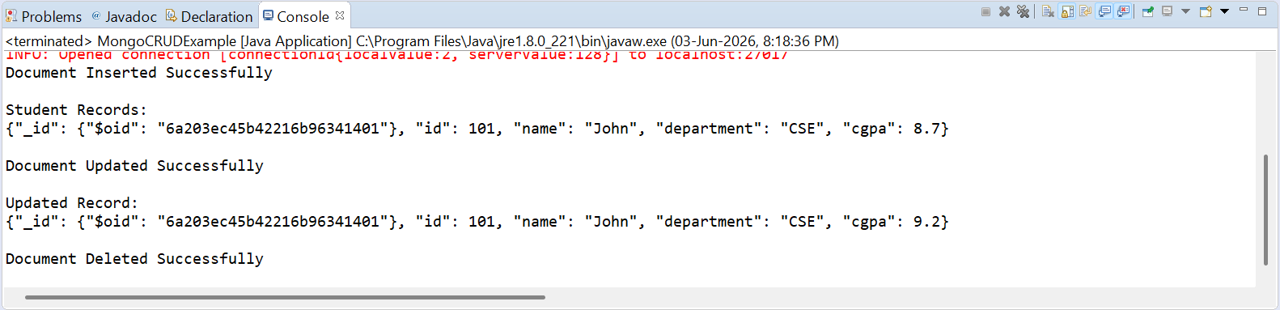

CODE:
import com.mongodb.client.*;
import com.mongodb.client.model.Filters;
import com.mongodb.client.model.Updates;
import org.bson.Document;

public class MongoCRUDExample {

public static void main(String[] args) {

// Connect to MongoDB
MongoClient mongoClient = MongoClients.create("mongodb://localhost:27017");

// Access database
MongoDatabase database = mongoClient.getDatabase("CollegeDB");

// Access collection
MongoCollection<Document> collection =
database.getCollection("Students");

// ==========================
// CREATE (Insert)
// ==========================
Document student = new Document("id", 101)
.append("name", "John")
.append("department", "CSE")
.append("cgpa", 8.7);

collection.insertOne(student);
System.out.println("Document Inserted Successfully");

// ==========================
// READ (Find)
// ==========================
System.out.println("\nStudent Records:");

FindIterable<Document> students = collection.find();

for (Document doc : students) {
System.out.println(doc.toJson());
}

// ==========================
// UPDATE
// ==========================
collection.updateOne(
Filters.eq("id", 101),
Updates.set("cgpa", 9.2)
);

System.out.println("\nDocument Updated Successfully");

// ==========================
// READ Updated Record
// ==========================
Document updatedStudent =
collection.find(Filters.eq("id", 101)).first();

System.out.println("\nUpdated Record:");
System.out.println(updatedStudent.toJson());

// ==========================
// DELETE
// ==========================
collection.deleteOne(Filters.eq("id", 101));

System.out.println("\nDocument Deleted Successfully");

// Close connection
mongoClient.close();
}
}

TASK 2 :
OUTPUT SCREENSHOT:
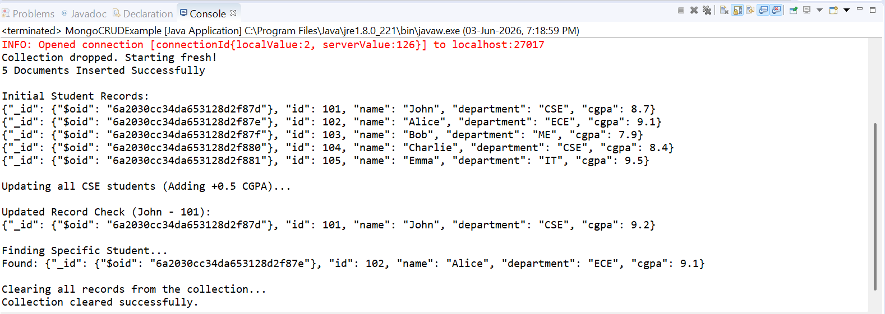
Code:
import com.mongodb.client.*;
import com.mongodb.client.model.Filters;
import com.mongodb.client.model.Updates;
import org.bson.Document;
import java.util.Arrays;
import java.util.List;

public class MongoCRUDExample {
public static void main(String[] args) {
// Connect to MongoDB
MongoClient mongoClient = MongoClients.create("mongodb://localhost:27017");

// Access database
MongoDatabase database = mongoClient.getDatabase("CollegeDB");

// Access collection
MongoCollection<Document> collection = database.getCollection("Students");

collection.drop();
System.out.println("Collection dropped. Starting fresh!");
// ==========================
// CREATE (Insert Many)
// ==========================
Document student1 = new Document("id", 101).append("name", "John").append("department", "CSE").append("cgpa", 8.7);
Document student2 = new Document("id", 102).append("name", "Alice").append("department", "ECE").append("cgpa", 9.1);
Document student3 = new Document("id", 103).append("name", "Bob").append("department", "ME").append("cgpa", 7.9);
Document student4 = new Document("id", 104).append("name", "Charlie").append("department", "CSE").append("cgpa", 8.4);
Document student5 = new Document("id", 105).append("name", "Emma").append("department", "IT").append("cgpa", 9.5);

List<Document> studentList = Arrays.asList(student1, student2, student3, student4, student5);
collection.insertMany(studentList);
System.out.println(studentList.size() + " Documents Inserted Successfully");

// ==========================
// READ (Find All)
// ==========================
System.out.println("\nInitial Student Records:");
for (Document doc : collection.find()) {
System.out.println(doc.toJson());
}

// ==========================
// UPDATE (Update Many)
// ==========================
System.out.println("\nUpdating all CSE students (Adding +0.5 CGPA)...");
collection.updateMany(
Filters.eq("department", "CSE"),
Updates.inc("cgpa", 0.5)
);

// ==========================
// READ Updated Record
// ==========================
Document updatedStudent = collection.find(Filters.eq("id", 101)).first();

System.out.println("\nUpdated Record Check (John - 101):");
// null check to avoid runtime error
if (updatedStudent != null) {
System.out.println(updatedStudent.toJson());
} else {
System.out.println("Error: Student 101 not found.");
}

// ==========================
// FIND SPECIFIC DOCUMENT
// ==========================
System.out.println("\nFinding Specific Student...");
Document doc = collection.find(Filters.eq("id", 102)).first();

// null check to avoid runtime error
if (doc != null) {
System.out.println("Found: " + doc.toJson());
} else {
System.out.println("Error: Student 102 not found.");
}

// ==========================
// DELETE (Delete Many)
// ==========================
System.out.println("\nClearing all records from the collection...");
collection.deleteMany(new Document());
System.out.println("Collection cleared successfully.");

// Close connection
mongoClient.close();
}
}

